Eastern Tiger Salamander
(Ambystoma tigrinum)
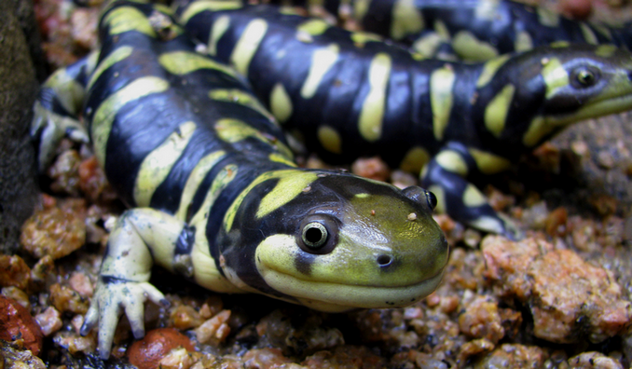
Habitat and Range: From the Southern part of New York State over throughout most of the Midwest, down into Mexico and as far North as Canada. They live in burrows close to or adjacent to bodies of water.

Diet: They carnivorous animals eating a wide range of prey items from worms, insects, fish, other amphibians, and even small mammals at full size.

Conservation Status: They are considered of least concern throughout their entire range. In New York State they are considered critically endangered due to loss of natural habitat.

Biological Fact: They are largest species of land dwelling salamander growing to lengths of 14 inches. Like many species of salamander they produce a toxin on the outside of their body for use in defense from predation.

