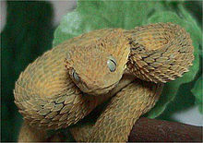
Bush Viper
(Atheris squamigera)

Habitat and Range: Found in rainforest regions of West and Central Africa.

Diet: When they are younger they eat mostly small lizards and frogs. As they grow larger their diet can range from lizards, frogs, small mammals and small birds.

Conservation Status: Threatened due to habitat loss.

Interesting Facts: They are ovoviviparous giving birth to what is considered live young. There is no specific antivenom for their toxin as of yet.

