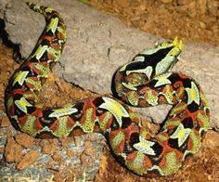

Rhino Viper
(Bitis nasicornis)
Range and Habitat: Found through out the forested areas of Central and Western Africa.

Diet: Mainly small mammals but will eat frogs, birds, and other small reptiles as well.

Conservation Status: Considered of Least Concern in the wild due to insufficient data.

Interesting Bio Facts: This species of snake has one of the most toxic venoms out of any snake in Africa. They breed only in the monsoon season in Africa and then normally found in around small fresh water pools.

